

|  |
| --- |
| ***BS Cyber Security Department AU*** |

|  |  |
| --- | --- |
| **Registration ID** | **233026** |
| **Submitted By** | **Muhammad Sohaib Rafiq** |
| **Submitted To** | **Iram Fatima Hashmi** |
| **Date of Submission** | **12/02/2024** |
| **Lab NO.** | **1** |
| **Subject** | **OS LAB** |

**Commands:**

**man nmap (shows the mannual for the nmap)**

**Output screenshot:**

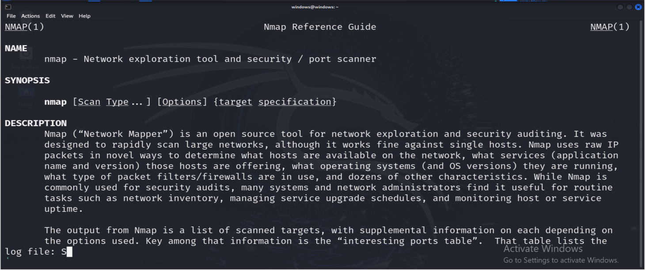

***List commands:***

***Ls shows the list :***

***And we have various options with list commands according to the need***

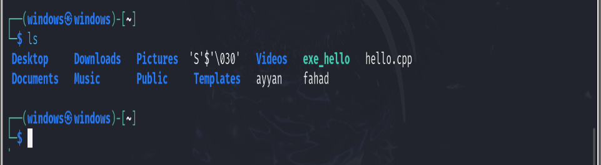

***And other commands for the list:***

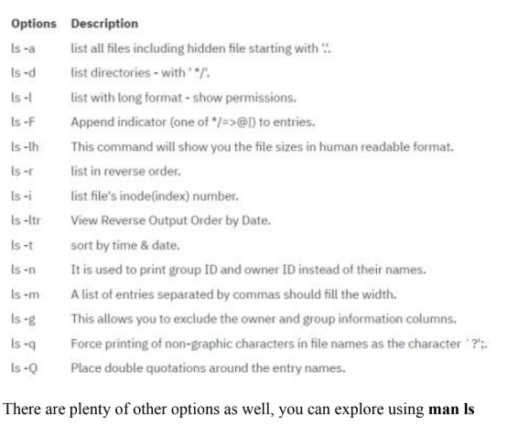

***The touch command with the -t:+ all touch commands***

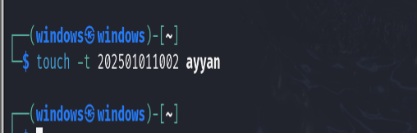

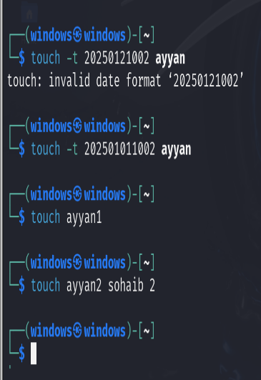

***Nano commands:***

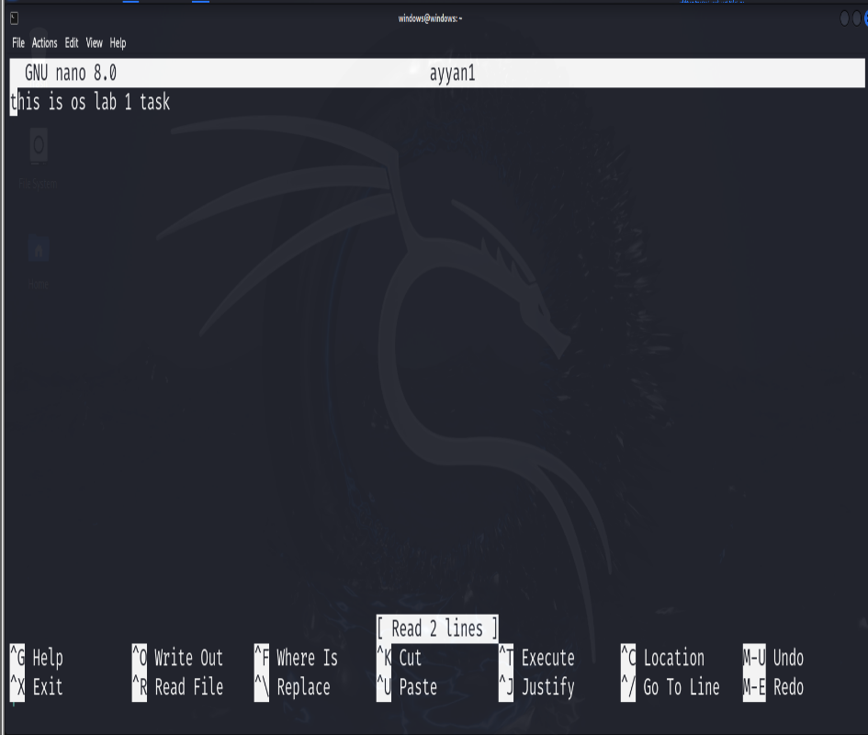

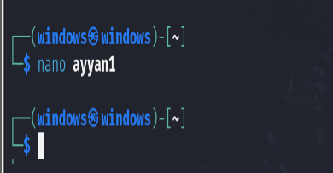

***Moving/renaming Files:***

***➢ Mv: Used to move or rename files or directories.***

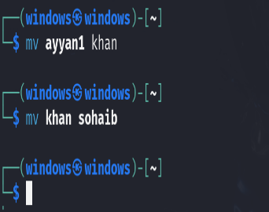

***Copying Files:***

***➢ Cp: Copies files and directories.***

***Cp commands:***

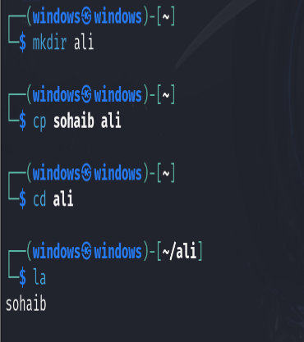

***Removing Files:***

***➢ Rm: Removes file.***

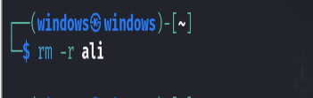

**Determining file type:**

**➢ File: Determines type of file using its content instead of extension.**

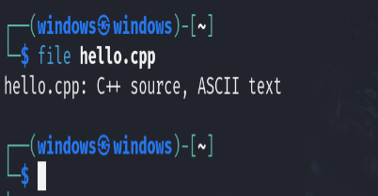

**Concatenating files:**

**➢ Cat: concatenate files and print on the standard output**

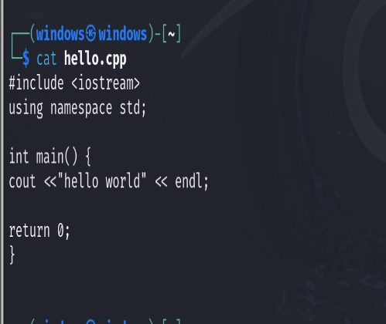

***Showing working directory:***

***➢ Pwd: Gives current working directory***

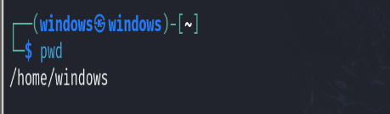

***Creating directory:***

***➢ Mkdir: Used to create new directories.***

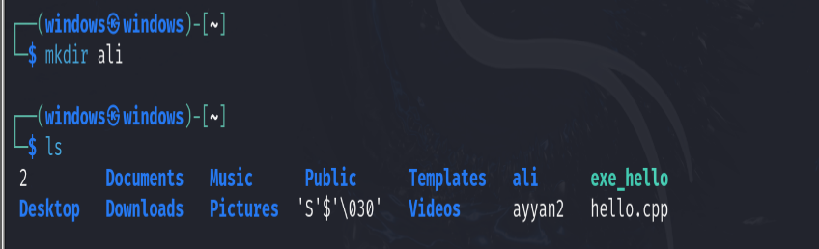

**Changing directory:**

**➢ Cd: Change working directory**

**cd <directoryname> (change current directory to specified directory)**

**cd .. (moves one level up)**

**cd – (move to last directory you were in)**

**cd / (move to root directory)**

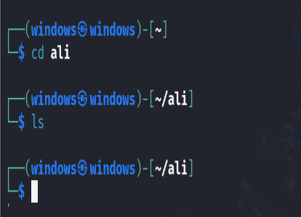

***Removing directory:***

***➢ Rmdir: Removes empty directory. Non-empty directories removed using rm -r***

***[directoryname].***

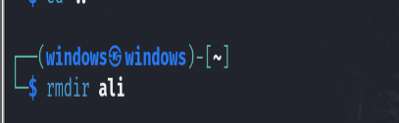

***File/Directory permissions:***

***Every file/directory on Linux has following permissions:***

***◼ Owner permissions: The owner's permissions determine what actions the owner of the***

***file can perform on the file.***

***◼ Group permissions: The group's permissions determine what actions a user, who is a***

***member of the group that a file belongs to, can perform on the file.***

***◼ Other (world) permissions: The permissions for others indicate what action all other***

***users can perform on the file.***

***And has following access modes:***

***➢ Read: Grants the capability to read, i.e., view the contents of the file.***

***➢ Write: Grants the capability to modify, or remove the content of the file.***

***➢ Execute: User with execute permissions can run a file as a program***

***Showing permission:***

***➢ Ls -l: List the permission of file or directory.***

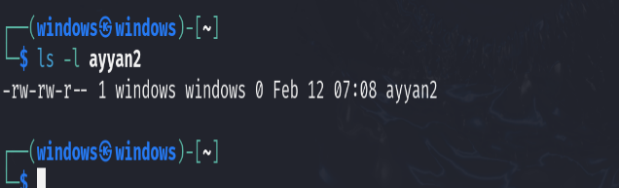

The returned permission has 10 characters.

◆ First character represents file type, - for file and d for directory.

◆ Next three characters (2-4) represent owner permission. Like in above returned

permission characters are rw- so owner has read and write permission.

◆ Next three character (5-7) represent group permissions. Like in above returned

permission characters are rw- so group has read and write permission.

◆ Last three character (8-10) represent other permissions. Like in above returned

permission characters are r-- so others have read permission.

***Modifying permission:***

***➢ Chmod: Modifies file or directory permissions.***

***Operators:***

***◆ +: adds permission to file or direcoty***

***◆ -: remove permission from file or directory***

***◆ =: sets the permission***

***Symbol for user categories:***

***◆ u: owner***

***◆ g: group***

***◆ o: other***

***◆ a: all***

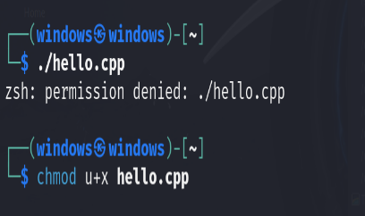

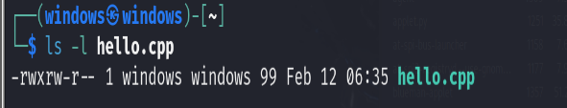

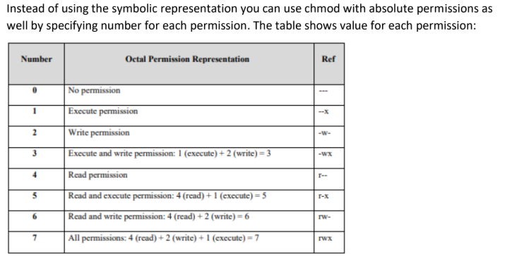

***Pipes and Filters:***

***You can connect two commands together so that the output from one program becomes the input***

***of the next program. Two or more commands connected in this way form a pipe. To make a pipe,***

***put a vertical bar (|) on the command line between two commands. When a program takes its***

***input from another program, it performs some operation on that input, and writes the result to the***

***standard output. It is referred to as a filter.***

***➢ Grep: Searches for pattern in file or output commonly used to find specific string or patterns***

***in files or output.***

***The id command used returns group names of the users which is then passed as input to***

***grep. Grep them searches for the specified pattern in that passed input and writes output.***

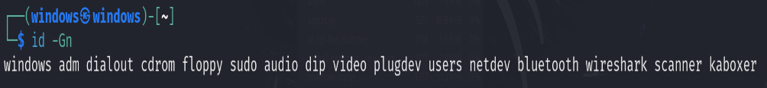

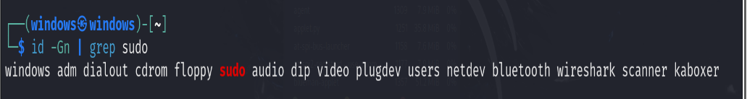

**In another example we have passed output of ls -l command to grep.**

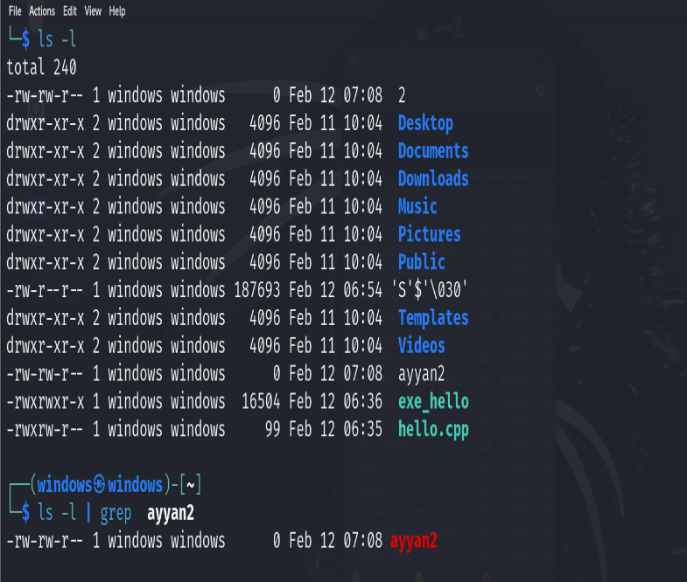

***It can be used individually as well without linking with any other command.***

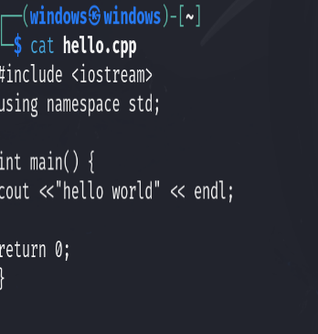

**Ps commands**

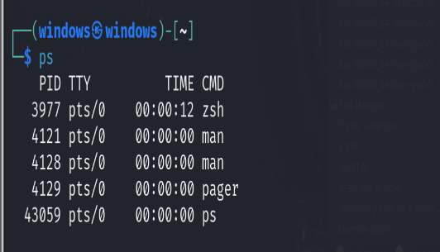

Clear:

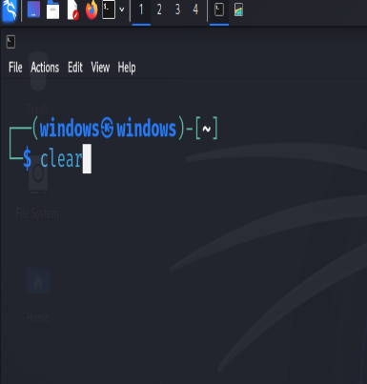

**Other basic commands:**

**➢ Clear: Clears the terminal screen**

**➢ Date: Display the date and time.**

**➢ Echo: Display message on screen.**

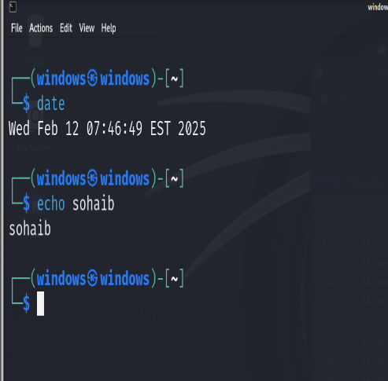

**➢ Free: Displays information about system memory usage.**

**➢ Id: Displays user and group ID and all group memberships of user.**

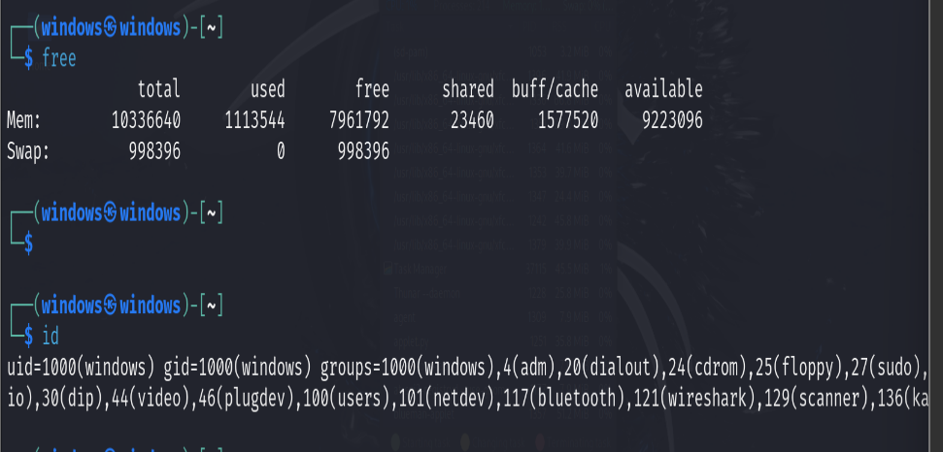

**➢ Wild card characters**

**◼ *: represent one or more characters**

**◼ ?: represent one character**

